BCSE497J - Project-I

EXPLAINABLE AND DRIFT-AWARE FRAUD DETECTION FOR DIGITAL PAYMENTS: A PRODUCTION-GRADE MLOPS PIPELINE

23BCE0608 | SHAMIK SENGUPTA
23BCE0622 | YASHASWINI KANAUJIA

Under the Supervision of

SHARMILA C
Assistant Professor, SCOPE
School of Computer Science and Engineering (SCOPE)

B.Tech.
in
Computer Science and Engineering

School of Computer Science and Engineering



September 2026

ABSTRACT
Digital payment ecosystems — particularly high-volume, real-time networks such as India’s UPI — are increasingly targeted by fraud that adapts faster than static, rule-based detection can react. This project presents an end-to-end fraud-detection pipeline that treats detection accuracy, explainability, and post-deployment reliability as equally important design goals, rather than optimizing a model in isolation.
At its core is a cost-sensitive XGBoost classifier trained on the anonymized ULB/Kaggle credit-card transaction dataset and tuned with Hyperopt to maximize Precision-Recall AUC under a 0.17% fraud base rate, since accuracy and ROC-AUC are misleading at this level of class imbalance. Every transaction flagged as fraud is paired with a SHAP-based, per-transaction explanation identifying the features that drove the decision, so a fraud analyst reviewing an alert sees a reason, not just a label. Live inference inputs are continuously compared against the training distribution using EvidentlyAI running in an isolated worker process, and the results are surfaced as Prometheus gauges and Grafana dashboards with burn-rate alerting on sustained drift.
The system is served through a FastAPI application hardened with liveness/readiness probes, structured logging, and measured Service Level Objectives — 99.5% availability and 99% of requests under 500ms — backed by Prometheus recording and alerting rules; a real load test exposed and fixed a 180x latency regression in the model-resolution path. The pipeline is version-controlled with DVC (data) and MLflow (experiments/models), containerized with Docker, deployed to a local Kubernetes cluster, and built, tested and published through a GitHub Actions CI/CD pipeline. It is designed to extend from this credit-card benchmark to a UPI-specific transaction dataset, aligning with SDG 9 (Industry, Innovation and Infrastructure) and SDG 16 (Peace, Justice and Strong Institutions) by strengthening the integrity of digital financial infrastructure.
Keywords — Fraud Detection, XGBoost, Explainable AI, SHAP, Data Drift, MLOps, Site Reliability Engineering, UPI.

TABLE OF CONTENTS
Sl.No | Contents | Page No.
 | Abstract | i
1. | INTRODUCTION | 1
 | 1.1 Background | 1
 | 1.2 Motivations | 1
 | 1.3 Scope of the Project | 1
2. | PROJECT DESCRIPTION AND GOALS | 3
 | 2.1 Literature Review | 4
 | 2.2 Research Gap | 4
 | 2.3 Objectives | 4
 | 2.4 Problem Statement | 4
 | 2.5 Project Plan | 5
3. | TECHNICAL SPECIFICATION | 6
 | 3.1 Requirements | 6
 | 3.1.1 Functional | 6
 | 3.1.2 Non-Functional | 7
 | 3.2 Feasibility Study | 7
 | 3.2.1 Technical Feasibility | 7
 | 3.2.2 Economic Feasibility | 8
 | 3.2.3 Social Feasibility | 8
 | 3.3 System Specification | 8
 | 3.3.1 Hardware Specification | 8
 | 3.3.2 Software Specification | 8
4. | DESIGN APPROACH AND DETAILS | 10
 | 4.1 System Architecture | 10
 | 4.2 Design | 11
 | 4.2.1 Data Flow Diagram | 11
 | 4.2.2 Use Case Diagram | 12
 | 4.2.3 Sequence Diagram | 13
5. | REFERENCES | 14

1. INTRODUCTION

1.1 Background
India’s Unified Payments Interface (UPI) and card-based digital rails now process billions of transactions a month, and that scale has made them a high-value target for fraud. Classical fraud-prevention systems rely on hand-written rules and static thresholds — a transaction is blocked because it crosses a fixed amount, or originates from a blacklisted device. Such rules are transparent and fast, but brittle: fraud patterns shift constantly, and a rule tuned to last month’s attacks is already stale against this month’s.
Machine learning reframes fraud detection as a highly imbalanced classification problem — legitimate transactions typically outnumber fraudulent ones several-hundred-to-one — where a model must learn subtle statistical patterns rather than fixed thresholds. Gradient-boosted tree models such as XGBoost have become a de facto standard for this setting because they handle imbalance well, train quickly on tabular data, and support exact SHAP-based explainability. However, a model that only reports a leaderboard metric is not a deployable system: it also needs to explain individual decisions to a human reviewer, detect when live traffic no longer resembles what it was trained on, and stay operable under real request load. This project builds that fuller system, not just the classifier at its center.
1.2 Motivation
Two observations motivated this project. First, most published fraud-detection work stops at a held-out evaluation metric — precision, recall, an AUC score — and treats deployment, monitoring, and explainability as someone else’s problem. In a real payment system, a model that cannot explain a decision cannot be used to freeze an account or deny a transaction, because that decision is contestable and must be justifiable to an analyst, a regulator, or the customer. Second, a model’s accuracy on the day it is trained says nothing about its accuracy six months later: transaction patterns, spending behaviour, and attacker tactics all drift, and a model silently becomes stale unless something is watching the input distribution and telling a human when it has moved.
Building and operating a small version of this problem end-to-end — training a cost-sensitive model, wiring per-decision explainability into the serving path, measuring drift continuously, and defining and defending Service Level Objectives under load — was chosen deliberately over a purely notebook-based model comparison, because it is this operational layer, not the choice of algorithm, that determines whether a fraud model survives contact with production.
1.3 Scope of the Project
The project covers the full path from raw data to an observable, deployed service. In scope: a cost-sensitive XGBoost classifier trained and versioned with MLflow on the anonymized ULB/Kaggle credit-card fraud dataset; per-transaction SHAP explanations for flagged predictions; EvidentlyAI-based input-drift monitoring wired to Prometheus/Grafana with burn-rate alerting; a FastAPI serving layer hardened with liveness/readiness probes, structured logging, and measured SLOs; DVC-based data versioning; containerization with Docker and orchestration on a local Kubernetes cluster; and a GitHub Actions CI/CD pipeline publishing to GHCR.
Out of scope for this stage: a real cloud deployment (AWS/EKS) — the system runs entirely locally to keep the project free of recurring cost and credential risk; horizontal scaling to multiple replicas, which the current per-process drift-buffer design does not yet support safely; automated drift-triggered retraining, deferred as future work; and validation on a real UPI transaction dataset, planned as an extension once the credit-card pipeline is fully validated — the architecture is deliberately dataset-agnostic to make that extension a data-layer change, not a redesign.

2. PROJECT DESCRIPTION AND GOALS
2.1 Literature Review

Six studies were reviewed to ground this project’s design choices, spanning classical credit-card fraud surveys, recent benchmark comparisons, explainability-focused frameworks, and UPI-specific work.
Popat and Chaudhary [1] survey classical machine-learning techniques — logistic regression, decision trees, random forests, SVMs and neural networks — for credit-card fraud detection. Their comparative review is broad but predates the XGBoost era and does not engage with class-imbalance handling in any depth; its main takeaway, echoed by later work, is that ensemble and tree-based methods consistently outperform single classifiers on imbalanced fraud data.
Wijaya et al. [2] run a rigorous, quantified comparison of classifiers (logistic regression, decision tree, random forest, XGBoost) crossed with data-balancing techniques (SMOTE, ADASYN, random oversampling, undersampling) on the same European credit-card benchmark this project uses. XGBoost combined with random oversampling produced the best result (F1 = 92.4%), which directly informed this project’s choice of a cost-sensitive XGBoost model. Their study, however, stops at the model: it does not address explainability, deployment, or monitoring.
Baisholan et al. [3] propose FraudX AI, an ensemble of random forest and XGBoost with SHAP-based interpretability, evaluated with PR-AUC and recall while preserving the dataset’s natural imbalance rather than resampling it away — reporting a PR-AUC of 97% and recall of 95%. Their emphasis on PR-AUC and SHAP closely matches this project’s own approach, but their interpretability is computed offline and post hoc; it is not wired into a live serving API the way this project’s SHAP explanations are.
Bodade and Pawade [4] review anomaly-detection and pattern-recognition approaches specifically for UPI fraud, synthesising transactional, behavioural and device-level features from the existing literature. Their review is timely and India/UPI-specific, but remains a literature synthesis: no explainability, monitoring, or live pipeline is discussed, and the authors note that ML approaches, while outperforming rule-based systems, largely remain at a prototype stage.
Kabir et al. [5] come closest to this project’s explainability angle, pairing a LightGBM classifier with SHAP explanations behind a Flask API prototype for UPI fraud, using transaction and behavioural features. Their work demonstrates high accuracy with per-transaction interpretability, but has no drift or monitoring component, evaluates on a single static dataset, and has no containerized deployment or CI/CD path — exactly the gaps this project’s later phases close.
Finally, Pelosi et al. [6] systematically review 136 records at the intersection of concept/data drift detection and explainability, and conclude that this intersection is still an open, largely uncatalogued research gap — explainability of drift is typically treated as an afterthought rather than a structured capability. Their review is conceptual and taxonomic rather than evaluated on real fraud data end-to-end.
Read together, these six studies motivate every major design decision in this project: a cost-sensitive XGBoost model evaluated on PR-AUC ([1], [2]), SHAP-based per-transaction explainability wired into a live API rather than computed offline ([3], [5]), and drift monitoring connected to that same explainable pipeline rather than treated as an unrelated afterthought ([6]) — specifically for the UPI/digital-payments context that existing work has so far only reviewed, not built end-to-end ([4], [5]).
2.2 Research Gap

Across the reviewed literature, three consistent gaps emerge. First, existing fraud-detection research is overwhelmingly focused on offline model development and evaluation — a train/test split and a leaderboard metric — rather than on what happens after a model is deployed. Second, the two application domains are studied in isolation: UPI-specific studies [4], [5] discuss deployment only superficially, while credit-card fraud research with rigorous benchmarking [1], [2] rarely addresses post-deployment monitoring at all. Third, explainability is typically computed offline and after the fact ([3]), and — as [6]’s systematic review confirms directly — no identified work integrates SHAP-based per-transaction explainability, continuous input-drift monitoring, and containerized, observable real-time deployment into a single pipeline for digital-payment fraud detection, UPI included.
This project is positioned directly in that gap: it treats explainability and drift-awareness not as optional extensions bolted onto a trained model, but as first-class parts of the serving path and the operational contract (SLOs, probes, alerting) the system is held to.
2.3 Objectives

The project pursues the following specific, measurable objectives:
1. Develop and validate a cost-sensitive XGBoost model for fraud detection that remains reliable under a severe class imbalance (~0.17% positive rate), tuned via Hyperopt to maximize Precision-Recall AUC on a stratified holdout.
2. Integrate SHAP-based explainability directly into the prediction pipeline, so every fraud-flagged transaction returns the specific features that drove the decision, not just a label.
3. Implement continuous drift monitoring that compares live transaction inputs against the training distribution and exposes the result as Prometheus metrics with threshold-based alerting.
4. Containerize and deploy the system using Docker and Kubernetes behind a GitHub Actions CI/CD pipeline, with Service Level Objectives, health/readiness probes and burn-rate alerting defining what “working” means for the service.
5. Extend the validated pipeline from the credit-card benchmark to a UPI-specific transaction dataset, so the same explainable, drift-aware, observable design generalizes to India’s real-time payments ecosystem.
SDG alignment: the project’s outcome — a more trustworthy, harder-to-defraud digital payment rail — contributes to SDG 9 (Industry, Innovation and Infrastructure) by strengthening the resilience of digital financial infrastructure, and to SDG 16 (Peace, Justice and Strong Institutions), specifically target 16.4 on reducing illicit financial flows.
2.4 Problem Statement

Digital-payment fraud detection must satisfy three requirements simultaneously that most published systems address one at a time: (i) detect fraud reliably despite a severe class imbalance where fewer than 2 in 1,000 transactions are fraudulent, without simply flagging everything to inflate recall; (ii) explain each flagged decision at the level of an individual transaction, so an analyst, a regulator or a customer can be given a concrete reason rather than an opaque score; and (iii) remain trustworthy after deployment, by detecting when live traffic drifts away from the distribution the model was trained on and by operating within a defined, monitored reliability contract (latency and availability objectives) rather than an unmeasured “it works on my machine” assumption.
This project addresses all three requirements as one connected system rather than as separable concerns, using the anonymized ULB/Kaggle credit-card dataset as the initial validation domain before extending to UPI-specific transaction data.
2.5 Project Plan
Fig. 1 shows the project’s phase-based plan. Work is organized into discrete, independently verifiable phases rather than a single monolithic build: each phase closes with an end-to-end verification step (tests passing, a live smoke test, or a load test) before the next begins, and every non-trivial engineering decision is logged with its rationale and rejected alternatives as it is made, not reconstructed afterwards.
By this Review-2 checkpoint (9 September 2026), Phases 1 through 4 are complete and verified: baseline diagnostics, the fraud-domain rebuild with a cost-sensitive XGBoost model, SHAP explainability, EvidentlyAI drift monitoring, DVC/Docker/CI/Kubernetes infrastructure, and SRE hardening (SLOs, health probes, burn-rate alerting) with a load-test-driven latency fix. The remaining work before the Final Review in the last week of October 2026 is the UPI-specific dataset extension and closing the drift-triggered-retraining gap noted as future work in this report.
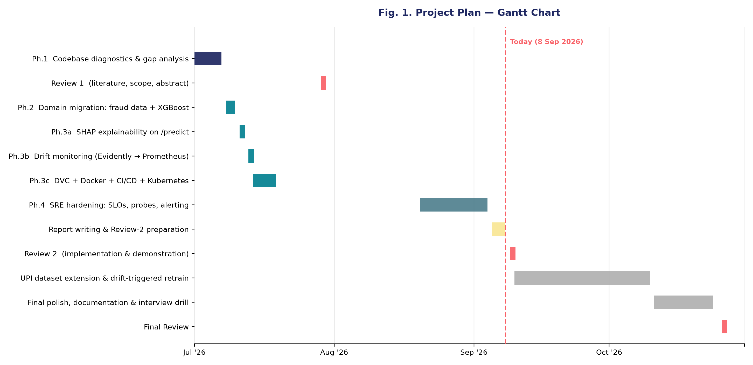
Fig. 1. Gantt chart
3. TECHNICAL SPECIFICATION
3.1 Requirements
3.1.1 Functional
- Transaction Scoring: the system shall accept a single transaction’s feature vector via POST /prediction_api and return a fraud/legitimate verdict with a calibrated fraud probability.
- Explainability: for every transaction flagged as fraud, the system shall return the top-N contributing features and their SHAP values, computed via a TreeExplainer over the trained XGBoost model.
- Batch Scoring: the system shall accept a CSV file of transactions via POST /batch_prediction and return predictions for every row as a downloadable CSV, archiving a copy locally for later review.
- Model Training and Versioning: the system shall provide a repeatable training pipeline (Hyperopt-tuned, cost-sensitive XGBoost) that logs every trial, its metrics, and the fitted model artifact to MLflow.
- Data Versioning: the system shall version the raw training dataset with DVC against a dedicated remote, independent of the Git history of the source code.
- Drift Monitoring: the system shall buffer live inference inputs and, once a configurable window fills, compare them against the training distribution using EvidentlyAI, exposing the result as Prometheus gauges.
- Health and Readiness: the system shall expose a liveness endpoint (/healthz) that reports process health independent of model state, and a readiness endpoint (/readyz) that reports 503 until a trained model is resident.
- Observability: the system shall expose HTTP request-count and latency metrics on /metrics for Prometheus scraping, and provide Grafana dashboards for SLO and drift visualization.
- Alerting: the system shall evaluate multiwindow, multi-burn-rate alerting rules against the availability and latency SLOs and against sustained input drift, and route firing alerts through Alertmanager.
- Continuous Integration and Delivery: the system shall automatically run its test suite, build a container image, and publish it to a container registry on every push to the main branch.
3.1.2 Non-Functional
- Performance: 99% of scoring requests shall complete in under 500ms, measured against the throughput and concurrency envelope established by load testing (§3.3 — ~30 req/s at ≤2–3 concurrent in-flight requests).
- Availability: the service shall maintain 99.5% non-5xx availability on a rolling 30-day window, tracked against an explicit error budget rather than an unstated aspiration.
- Scalability (documented limit): the service currently supports exactly one replica by design — the drift buffer and model cache are per-process state — and this constraint is documented rather than silently ignored; horizontal scaling is future work requiring an externalized buffer.
- Security: the container shall run as a non-root user with all Linux capabilities dropped and a RuntimeDefault seccomp profile; CORS and input validation (Pydantic schemas) shall guard the API boundary.
- Reproducibility: every trained model, its metrics, and the dataset version it was trained on shall be traceable end-to-end through MLflow and DVC.
- Maintainability: infrastructure (Prometheus rules, Grafana dashboards, Kubernetes manifests, CI workflow) shall be defined as reviewable, version-controlled configuration rather than manual, undocumented setup.
- Observability and Diagnosability: all serving-process logs shall be structured (JSON) so they can be correlated across a request’s model-resolution, prediction, and explanation stages.
3.2 Feasibility Study
3.2.1 Technical Feasibility
Every component of the stack is open-source, well-documented, and already validated on this exact project: XGBoost, scikit-learn, SHAP, and Hyperopt for modeling; FastAPI/Uvicorn for serving; MLflow and DVC for versioning; Docker, Kubernetes (via Docker Desktop’s local cluster) and GitHub Actions for build/deploy; and Prometheus/Grafana/Alertmanager for observability.
All of it runs on a single development laptop with no specialized hardware — training the model end-to-end takes minutes, not hours, because the dataset is small (~285,000 rows) and XGBoost is CPU-efficient. The main technical risk identified during the build — EvidentlyAI’s drift-checking dependency (litestar) colliding with FastAPI’s own multipart-parsing dependency at the Python import level — was diagnosed and resolved by isolating drift computation in a separate worker process, demonstrating that the team can debug and resolve nontrivial dependency-level conflicts, not just glue libraries together.
3.2.2 Economic Feasibility
The entire stack is free at the scale this project operates: all libraries and frameworks are open-source with permissive licenses, the container registry (GHCR) and CI minutes (GitHub Actions) are free for a public repository, and the Kubernetes cluster is Docker Desktop’s local, no-cost cluster rather than a billed cloud service.
The only cost incurred anywhere in the project is the team’s own development time. This is a deliberate choice, not an oversight: an earlier design considered real AWS services (S3/ECR/EKS, as in the original baseline this project was rebuilt from) but that path bills continuously even when idle and requires credential management the team judged unnecessary for a portfolio-stage system; it is documented as a future step if a live, internet-reachable deployment is ever required.
3.2.3 Social Feasibility
For a fraud analyst, the system’s SHAP-based explanations directly address a known adoption barrier for ML-based fraud tools: a black-box “fraud” label with no reason is hard to act on and easy to distrust, whereas a ranked list of contributing features gives the analyst something to verify against the transaction itself. For the payment ecosystem more broadly, faster and more explicable fraud detection reduces the number of legitimate customers wrongly inconvenienced and the number of fraudulent transactions that succeed, benefiting both consumers and institutions.
Ethically, the credit-card dataset used for validation is already PCA-anonymized at the source (the raw features are anonymized principal components, not identifiable transaction details), and the design explicitly avoids over-triggering: explanations and alerts are computed only for flagged transactions and sustained drift respectively, rather than surfacing noise that would train reviewers to ignore the system. The main open ethical consideration — carried forward honestly as a known gap rather than hidden — is that a purely data-driven model can still encode bias present in its training data, which is a standing item for the UPI-extension phase to re-evaluate against India-specific transaction patterns.
3.3 System Specification
3.3.1 Hardware Specification
- Processor: Intel Core i5 / AMD Ryzen 5 or higher (quad-core or better recommended for parallel Docker builds and Hyperopt trials)
- Memory (RAM): 8 GB minimum; 16 GB recommended (the Kubernetes pod is configured for up to 2 GiB, alongside Docker Desktop, MLflow, and the drift worker subprocess running concurrently)
- Storage: 10 GB free disk space (the built container image is ~2.7 GB; the raw dataset is ~144 MB; local MLflow/DVC artifacts add a few hundred MB more)
- Graphics Processing Unit (GPU): Not required — XGBoost trains efficiently on CPU at this dataset scale (~285,000 rows); no GPU-dependent component exists anywhere in the pipeline
- Monitor: Standard display; no specialized visualization hardware required
3.3.2 Software Specification
- Operating System: Windows 11 (development) with Docker Desktop’s WSL2 backend; Linux (Ubuntu 22.04+/Debian) for the containerized runtime (python:3.10-slim-bookworm)
- Programming Languages: Python 3.10
- Development Environment: Visual Studio Code / PyCharm, Git, Docker Desktop (with the Kubernetes cluster feature enabled)
- Libraries and Frameworks: FastAPI 0.103, Uvicorn, Pydantic 2.4, XGBoost 2.0, scikit-learn 1.2, Hyperopt 0.2, SHAP 0.44, EvidentlyAI 0.7, MLflow 2.13, pandas, NumPy, prometheus-fastapi-instrumentator
- Database: MLflow file-store (mlruns/) for experiment tracking and model artifacts; DVC with a local-filesystem remote for dataset versioning
- Security Tools: Non-root container user, dropped Linux capabilities, seccomp RuntimeDefault profile, FastAPI CORS middleware, Pydantic schema validation at the API boundary
- Containerization & Orchestration: Docker (multi-stage build), Docker Compose, Kubernetes (Docker Desktop’s local cluster) with Deployment/Service manifests
- CI/CD: GitHub Actions (test + build-and-push jobs), GitHub Container Registry (GHCR)
- Monitoring & Alerting: Prometheus (metrics + recording/alerting rules), Grafana (SLO and drift dashboards), Alertmanager (burn-rate alert routing)
- Load Testing: k6 (k6_prediction.js)

4. DESIGN APPROACH AND DETAILS

4.1 System Architecture
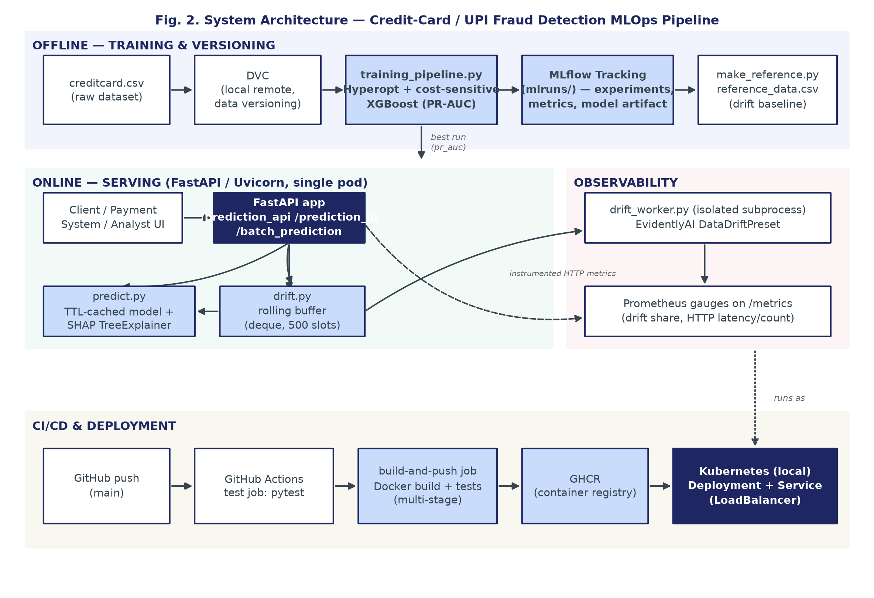
Fig. 2. System Architecture
Fig. 2 shows the system’s end-to-end architecture across four concerns. The offline training path (top) versions the raw dataset with DVC, trains a cost-sensitive XGBoost model via a Hyperopt search logged to MLflow, and regenerates the drift-reference sample from the same training split.
The online serving path (bottom-left) is a single FastAPI/Uvicorn process exposing the scoring, explanation, batch, and health/readiness endpoints; predict.py resolves and caches the best MLflow run (TTL-based) and wraps it with a SHAP TreeExplainer, while drift.py buffers inference inputs and hands off to an isolated worker subprocess once a window fills — isolated specifically because EvidentlyAI’s dependency chain cannot be imported inside the same process as FastAPI.
The observability path (bottom-right) turns both the drift worker’s output and the API’s own instrumented HTTP metrics into Prometheus gauges. The CI/CD path (bottom) tests, builds, and publishes the container image on every push, and the resulting image is what the local Kubernetes Deployment and LoadBalancer Service actually run. The architecture deliberately keeps these four concerns loosely coupled — the serving path never imports Evidently, the CI path never touches AWS, and the Kubernetes manifests are explicit about which parts of the design (a single replica, a host-mounted model volume) are local-cluster conveniences rather than production claims.
4.2 Design
The following diagrams present the system from three complementary views: the data-flow view (what moves between processes and stores), the use-case view (who uses the system and for what), and the request-level sequence view (how one scoring request actually executes). A class diagram is intentionally omitted — the codebase is organized as a small set of stateless processing modules and Pydantic schemas rather than a rich object model, so a UML class diagram would not convey more than the module list already given in §3.3.2.
4.2.1 Data Flow Diagram
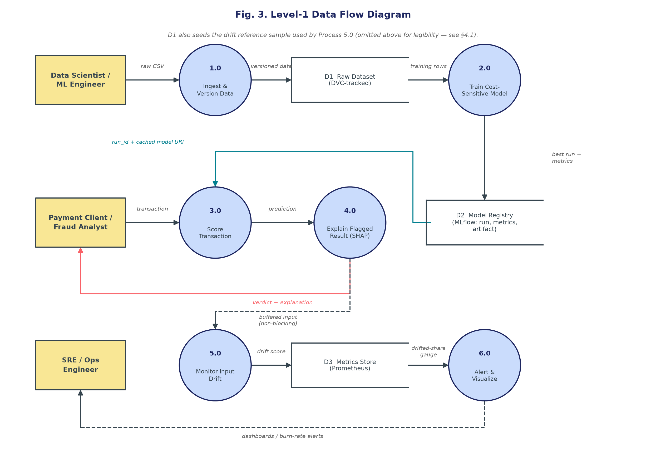
Fig. 3. Level-1 Data Flow Diagram
Fig. 3 traces two flows that share the trained model as their hand-off point: a training flow (1.0→2.0) that turns a versioned raw dataset into a registered model, and a serving flow (3.0→4.0→5.0→6.0) that scores a transaction, explains it when flagged, buffers it for drift comparison, and surfaces the aggregated result to dashboards and alerts. The dashed lines mark asynchronous, non-blocking hand-offs — buffering an inference input and pushing dashboard/alert data — a deliberate design choice so that scoring latency is never coupled to the cost of a drift computation or a metrics scrape.
4.2.2 Use Case Diagram
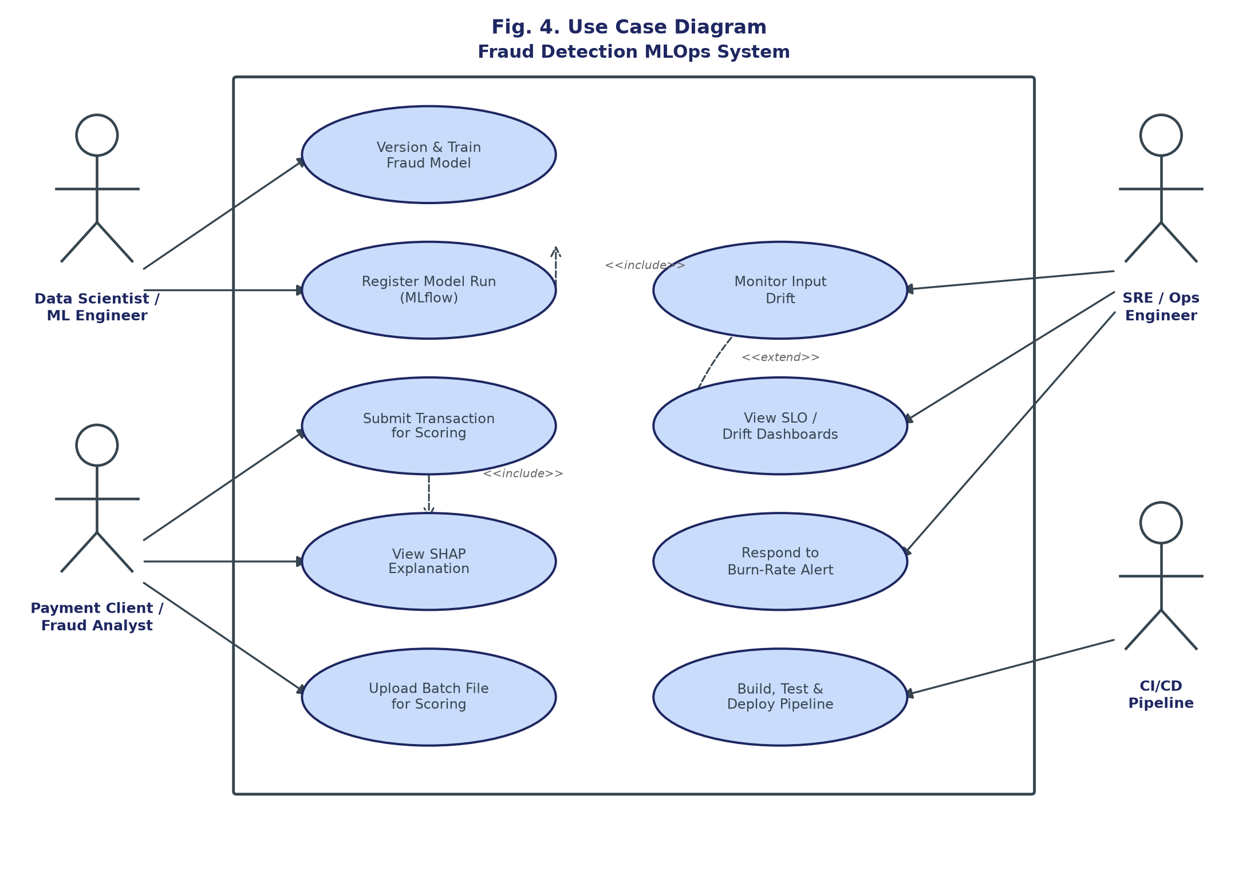
Fig. 4. Use Case Diagram
Fig. 4 identifies four actors. The Data Scientist/ML Engineer trains and registers models. The Payment Client/Fraud Analyst is the system’s primary runtime user, submitting transactions or batch files and consuming SHAP explanations — Submit Transaction for Scoring includes View SHAP Explanation as a sub-flow for flagged transactions. The SRE/Ops Engineer consumes dashboards and responds to alerts; Respond to Burn-Rate Alert is modeled as extending Monitor Input Drift, since an alert is only raised when a drift check crosses the configured threshold. The CI/CD Pipeline is modeled as a non-human actor because it triggers Build, Test & Deploy autonomously on every push.
4.2.3 Sequence Diagram
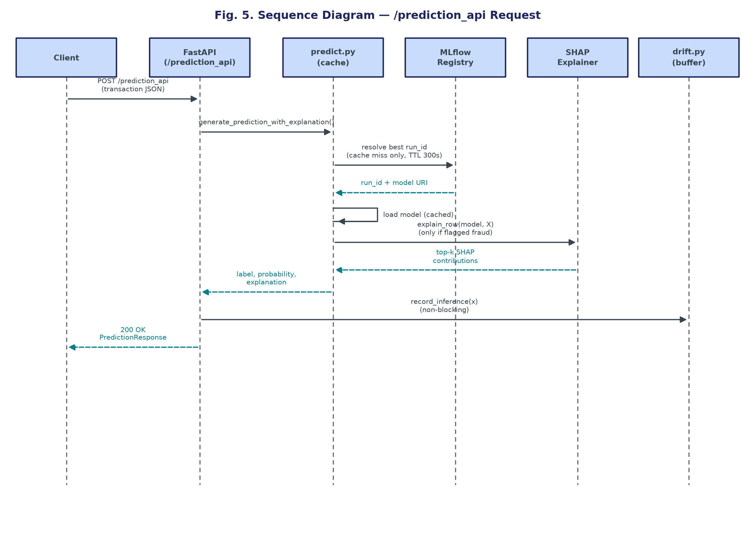
Fig. 5. Sequence Diagram — /prediction_api Request
Fig. 5 traces a single POST /prediction_api call end-to-end. The dominant recurring cost in this path — measured directly, not estimated — was the uncached MLflow run-id resolution, which is why predict.py’s model/explainer cache and the TTL-based resolution are shown explicitly rather than abstracted away: they are the specific fix behind the throughput improvement reported in §3.3. Explanation is computed only when the prediction is fraud-flagged, and the drift-buffer hand-off is issued after the response path is already resolved, so it can never add latency to what the client waits for.

5. REFERENCES
Weblinks:
- Machine Learning Group – ULB, “Credit Card Fraud Detection” dataset, Kaggle. [Online]. Available: https://www.kaggle.com/datasets/mlg-ulb/creditcardfraud
- XGBoost Developers, “XGBoost Documentation.” [Online]. Available: https://xgboost.readthedocs.io/
- S. Lundberg, “SHAP Documentation.” [Online]. Available: https://shap.readthedocs.io/
- Evidently AI, “Evidently Documentation.” [Online]. Available: https://docs.evidentlyai.com/
Journals:
[2] M. G. Wijaya, M. F. Pinaringgi, A. Y. Zakiyyah, and Meiliana, “Comparative Analysis of Machine Learning Algorithms and Data Balancing Techniques for Credit Card Fraud Detection,” Procedia Comput. Sci., vol. 245, pp. 677–688, 2024.
[3] N. Baisholan, J. E. Dietz, S. Gnatyuk, M. Turdalyuly, E. T. Matson, and K. Baisholanova, “FraudX AI: An Interpretable Machine Learning Framework for Credit Card Fraud Detection on Imbalanced Datasets,” Computers, vol. 14, no. 4, p. 120, 2025.
[4] S. S. Bodade and P. P. Pawade, “Review Paper on UPI Fraud Detection Using Machine Learning,” Int. J. Res. Appl. Sci. Eng. Technol. (IJRASET), 2023, doi: 10.22214/ijraset.2023.57551.
[5] S. Kabir, V. Khuraijam, and V. Sonika, “UPI Transaction Fraud Detection Using Machine Learning: A Data-Driven Approach,” Int. J. Sci. Res. Eng. Manage. (IJSREM), 2025.
[6] D. Pelosi, D. Cacciagrano, and M. Piangerelli, “Explainability and Interpretability in Concept and Data Drift: A Systematic Literature Review,” Algorithms, vol. 18, no. 7, p. 443, 2025.
Conference:
[1] R. R. Popat and J. Chaudhary, “A Survey on Credit Card Fraud Detection Using Machine Learning,” in Proc. 2nd Int. Conf. Trends Electron. Informatics (ICOEI), 2018, pp. 1120–1125.
Book:
- A. Géron, Hands-On Machine Learning with Scikit-Learn, Keras, and TensorFlow, 3rd ed. Sebastopol, CA, USA: O’Reilly Media, 2022.

